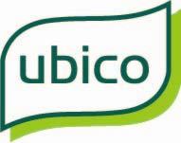

Health and Safety Policy Statement

**For All Employees and Contractors at** **Ubico**

**DOCUMENT HISTORY**

|  |  |
| --- | --- |
| **Document Location:** | \\Ubico.uk\data\Corporate\Corporate Support\Policies and Templates\Policies Final versions\Health and Safety Policy Statement_v14.docx |

**This document has been approved by:**

|  |  |  |
| --- | --- | --- |
| **Date** | **Name** | **Job Title** |
| Annually From 2012 to 2020 |  | Board of Directors |
| Annually from April 2021 to April 2023 |  | Managing Director, Trade Unions,  Board of Directors |
| April 2024 |  | Managing Director, Trade Unions, Board of Directors |
| April 2025 |  | Managing Director, Trade Unions, Board of Directors |

|  |  |  |
| --- | --- | --- |
| **Version Number** | **Version Date** | **Summary of Changes** |
| V1 | 2012 |  |
| V2 | Jul 13 |  |
| V3 | Dec 13 | Minor word changes |
| V4 | Jun 15 | Annual review and updated |
| V5 | Jun 16 | Annual review and updated |
| V6 | Jul 17 | Annual review and update of MD |
| V7 | Aug 18 | Annual review and updated |
| V8 | Apr 19 | Annual review and updated |
| V9 | Mar 20 | Annual review and update of MD, update of job titles |
| V10 | Mar 21 | Annual review and update of job titles where required |
| V11 | Mar 22 | Annual review and updated of job titles |
| V12 | Mar 23 | Annual review, minor updates to MD foreword |
| V13 | Mar 24 | Annual Review, include Unite Union |
| V14 | Mar 25 | Annual review, update of job titles |

**Contents**

Foreword By Managing Director 3

Health & Safety Policy Statement 4

1. Organisational Structure and Values 5

2. Roles and responsibilities 7

3. Consultation 8

4. Monitoring and audit 9

5. Arrangements 10

Foreword by Managing Director

Ubico’s first priority is keeping our employees, contractors, visitors and public who interact

with our services safe and well.

Being and staying safe is everyone’s responsibility. We expect and require that all employees abide by our Health and Safety Policy Statement and our procedures.

Plan. Do. Check. Act. These simple words underpin how we manage health and safety.

* We must **PLAN** our approach to assess where we are now and where we want to be.
* We must **DO** the work to assess risks and implement the plans we make.
* We must **CHECK** our performance and investigate accidents, incidents and near-misses
* We must **ACT** on any lessons we learn.

Ubico’s corporate values, designed through positive engagement with our employees, set

clear guidance and expectations for all. The value of “Be Safe” is universally recognised by

employees as being the most important behaviour that we must expect everyone to

recognise and adopt. Working in line with this value helps to reinforce a positive

organisational culture that places continuous improvement in health and safety at its core.

This is demonstrated by the company’s ongoing successful re-accreditation to ISO45001. Our internal training centre has significantly strengthened our training program and its delivery, as we continue to offer a range of training programmes to refresh and develop knowledge and skills. As a company, we remain committed to continually reviewing our existing processes to drive improvement and strengthen our approach to health and safety.

My signature below represents Ubico’s commitment to this Health and Safety Policy

Statement and to working in partnership to remain vigilant, prevent complacency and identify

ways that we can improve Ubico’ health and safety performance.

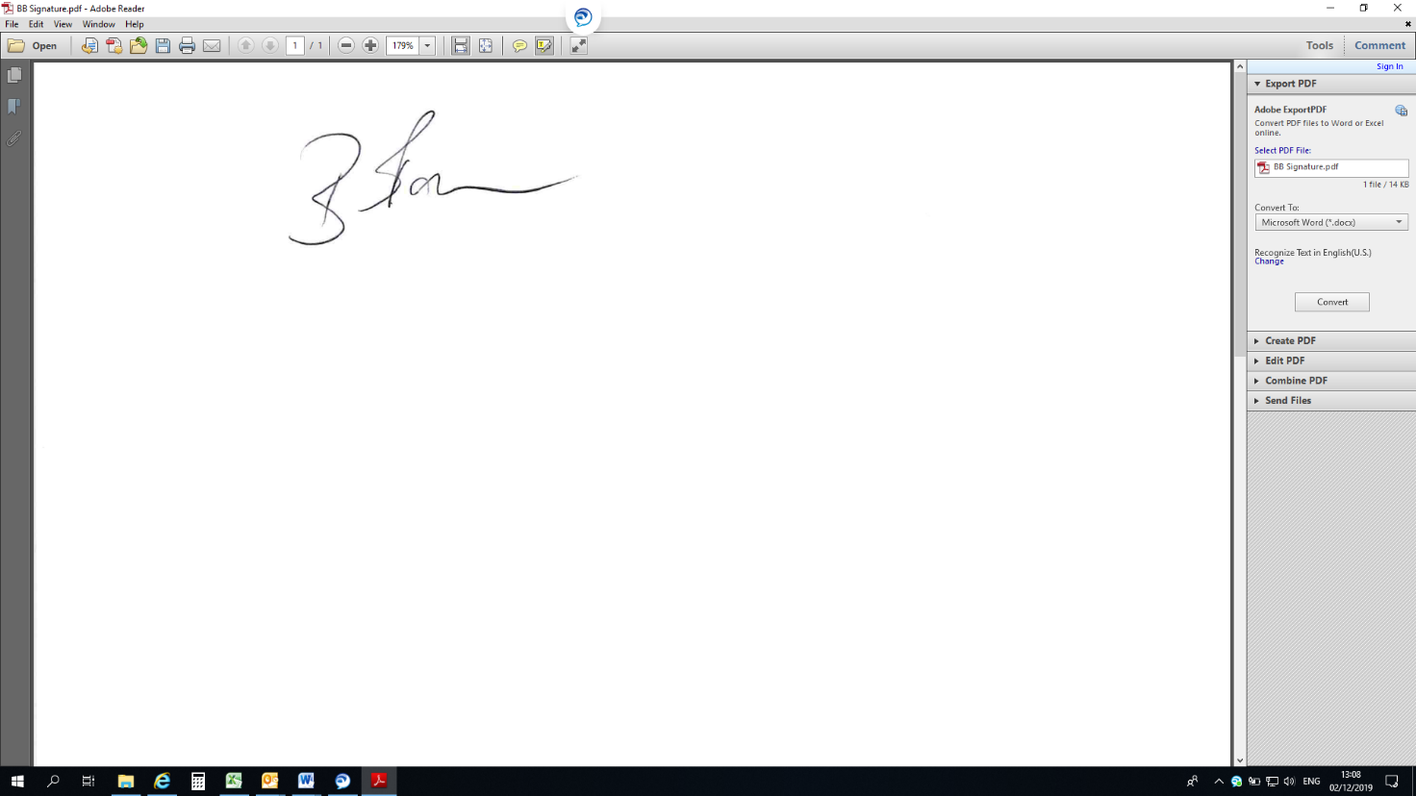

Beth Boughton

Managing Director

April 2025

Health & Safety Policy Statement

Ubico recognises and accepts its statutory responsibility to ensure so far as is reasonably practicable, the health, safety and wellbeing of its employees and those affected by our activities.

This will be achieved by:

* Developing a positive health and safety culture in all undertakings, which secures the commitment and participation of employees at all levels.
* Assessing the risks to the health and safety of our employees and to anyone else who may be affected by our undertakings with the aim of eliminating or controlling the hazards/risks, so far as is reasonably practicable.
* Making arrangements for the effective planning, organisation, control, monitoring and review of the preventive and protective measures identified as being necessary by risk assessments.
* Providing information, instruction, training, and supervision to employees and others as is necessary to implement and maintain high standards of health and safety.
* The provision and maintenance of a working environment for employees that is safe, without risks to health, and adequate as regards to facilities and arrangements for their welfare at work, so far as is reasonably practicable.
* Consulting with and involving employees in matters relating to their health and safety.
* Ensuring emergency procedures are in place, tested and reviewed.
* Monitoring safety performance of contractors.
* Allocating adequate resources for health and safety.

We undertake to review and develop this policy and our health and safety management system at least annually, in the light of changes in Ubico’s activities, developments in health and safety legislation and best practice and to ensure it continues to meet the needs of Ubico.

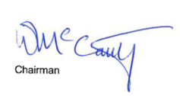



Chair of the board Managing Director

April 2025

1. Organisational Structure and Values

The structure chart below shows the hierarchy of health and safety responsibilities throughout Ubico.

**Board of Directors**

Unions

Employees

Employees

Managing Director

Head of Compliance

Operations Manager

Finance Director

Operations Director

Executive Support Manager

Deputy Finance Director, Head of Compliance

Head of Fleet Operations, Head of Operations Head of SHEQ

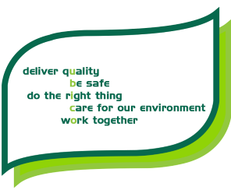

|  |  |
| --- | --- |
| **Deliver Quality** | What we do, we do well |
| **Be Safe** | Look out for yourself and others |
| **Do the Right thing** | Make good decisions and treat people with respect |
| **Care for our Environment** | Protect where we live and work. Strive to be cleaner and greener |
| **Work Together** | Communicate well and help each other |

1. Roles and responsibilities

**Board members shall:**

* Provide strategic direction and oversight of corporate health and safety policies and procedures.
* Ensure that suitable and adequate resources and strategic direction are available to discharge Ubico’ health and safety responsibility.
* Monitor the overall performance of Ubico’s health and safety management system.

**Managing director shall:**

* Take overall responsibility for health and safety across Ubico and lead in setting corporate policy, culture and direction.

**Senior leadership team shall:**

* Ensure that robust health and safety management systems, arrangements and organisation exist in each department.
* Support the managing director in meeting their health and safety responsibilities, including culture to Ubico as a whole.
* Support the work of the safety health environment and quality team.

**Managers shall:**

* Keep up to date with current legislation and best practice.
* Implement health and safety policies and procedures as applicable in their area of responsibility.
* Ensure employees and others comply with the requirements of their departmental health and safety documentation as well as any specific health and safety requirement.
* Ensure that all work-related hazards are identified and suitable and sufficient risk assessments are carried out and adequate control measures implemented.
* Ensure their employees have adequate levels of competency to complete their work tasks safety and where necessary are provided with appropriate health and safety training relevant to the hazards in their work.
* Report and investigate accidents and incidents as required.
* Report injuries, diseases and dangerous occurrences to the Health and Safety Executive.

**Head of Safety health environment and quality shall:**

* Fulfil the role of ‘Competent Person’ as set out in the Management of Health and Safety at Work Regulations 1999.
* Provide appropriate and timely advice and support to managers and employees.
* Keep up to date with current legislation and best practice.
* Investigate incidents and near misses as appropriate.
* Liaise with enforcing authorities.

**Building managers shall:**

* Have specific responsibility for working with the leaseholder in maintaining safe buildings for occupiers and communicating relevant health and safety information as appropriate to the occupants in accordance with relevant legislation.

**Employees shall:**

* Familiarise themselves with the contents of this policy and health and safety policies and procedures that relate to their work.
* Attend all mandatory health and safety training relevant to the hazards in their work.
* Work with due regard to the health and safety of themselves and others affected by their work activities.
* Co-operate with and support managers in meeting their health and safety responsibilities.
* Not intentionally or recklessly interfere with or misuse anything provided in the interests of health, safety or welfare.
* Draw attention to any health and safety hazards or deficiencies to their manager or the safety health environment and quality team.

**Contractors shall:**

* Co-operate and communicate with Ubico on all relevant health and safety matters.
* Meet the health and safety standards required of them whilst carrying out their work activities on behalf of Ubico.

1. Consultation

Under the Safety Representatives and Safety Committees Regulations 1977 (as amended) and the Health and Safety (Consultation with Employees) Regulations 1996 (as amended), Ubico must have in place arrangements for consulting with its employees.

At Ubico, safety representatives are consulted through the Ubico Consultative Forum at three monthly intervals.

Departmentally, managers will consult with their employees on all matters affecting their health and safety including risk assessments.

**Trade union and employee safety representatives**

Under the Safety Representatives and Safety Committees Regulations 1977 (as amended), recognised trade unions are entitled to appoint one or more safety representatives to represent their members on health and safety matters.

The recognised trade unions at Ubico are Unison, GMB and Unite the Union.

Where the workforce is not represented by trade unions, employers must make alternative arrangements for consulting with their employees. This can be done by employees electing an employee representative.

**Under the legislation, both trade union representatives and employee representatives can:**

* Carry out inspections of the workplace.
* Investigate accidents and incidents and complaints from their members regarding health and safety matters.
* Receive copies of reports from the HSE.
* Receive information relating to the safety of plant, equipment, substances or work methods.
* View inspection documents.
* Attend health and safety committees.

**Health and Safety Committee**

The Health and Safety Committee at Ubico is part of the Ubico Consultative Forum (UCF).

The health and safety role of the UCF is to consider and make recommendations on:

* Ubico health and safety policies.
* Accident, incident and occupational ill-health reports and to make recommendations for corrective action as necessary.
* Reports and information provided by inspectors of the enforcing authorities.
* Concerns raised by trade union and employee safety representatives or other Committee members.
* Reports on health and safety inspections, audits and other monitoring activities.
* Arrangements for ensuring effective communication of health and safety information.

**The UCF is attended by:**

* Managing director or their representative as chair
* Managers
* Members of the company’s safety health environment and quality team
* HR business partner
* Trade union and employee safety representatives

1. Monitoring and audit

Monitoring is by way of inspection of activities, workplaces and properties owned or leased by Ubico. These take place at regular intervals and a report produced with an action plan for implementation.

Audits are carried out on a regular basis and the results communicated to the Ubico Consultative Forum for consideration and if necessary, action. Minutes of the Consultative Forum H&S committee may be scrutinised by the board.

1. Arrangements

Ubico policies set out the arrangements in place to achieve the health and safety objectives in this policy.

These policies form part of this overarching policy and are available either on the intranet or as electronic documents.

Ubico policies are drawn up in consultation with relevant employees and take into account legal requirements and best practice guidance.

They are approved by an executive director and through the Ubico Consultative Forum and are reviewed at stated intervals, and as necessitated by changes to legislation and best practice or identified shortcomings.